**Setting Up Application Environment**

**Create account on sendgrid**

|  |  |
| --- | --- |
| Date | 31-10-2022 |
| Team ID | PNT2022TMID31805 |
| Project Name | Personal Expense Tracker Application |

**Step 1:**

Go to official website: https://sendgrid.com/ then click start for free

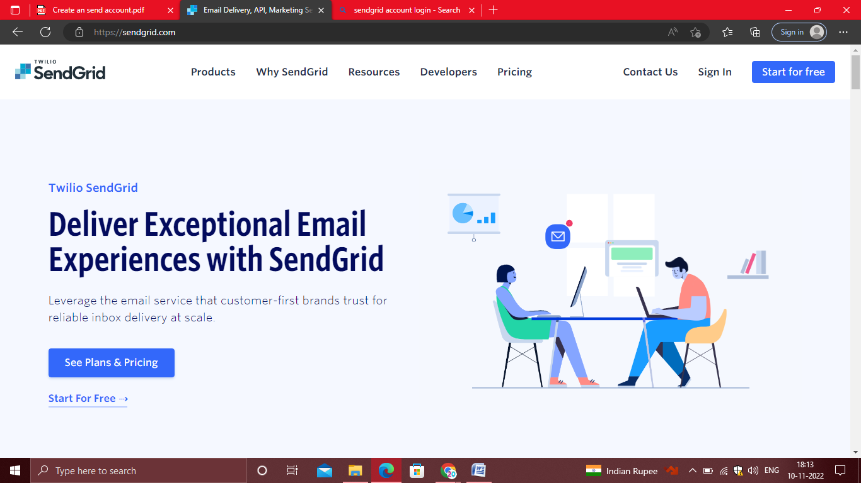

**Step 2:**

Then go the Registration Page, you need to give all the details required for creating a sendgrid account and finally click create button. The below screenshot will show the registration process.

**Step 3:**

Then it will redirect you to a home page of your sendgrid account.

**Step 4:**

Finally, you have created your account and you can access the sendgrid account.

